Exclude Students
- To exclude students from being included in calculations, begin by clicking on the student button in upper left corner of the chart.
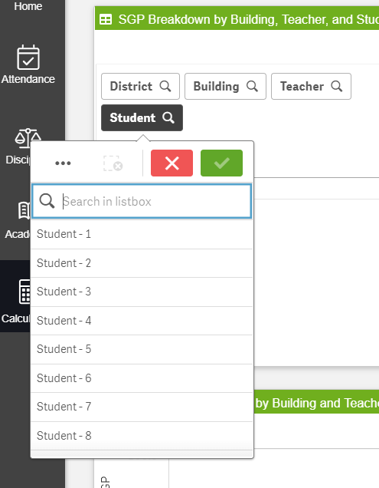
- Click on the names of the students to be excluded. They will be identified in green with a checkmark. The calculator will begin to calculate data only for the students selected.
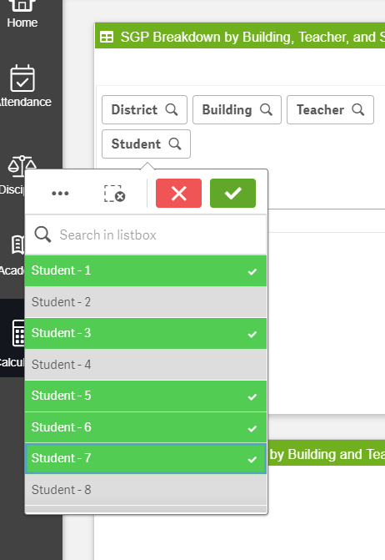
- Click the 3 dots in upper left of dropdown and click on select excluded. This will swap the students who have been selected for those that were not, allowing the calculations to reflect the larger group of students. Click the green checkmark to proceed with viewing calculations.
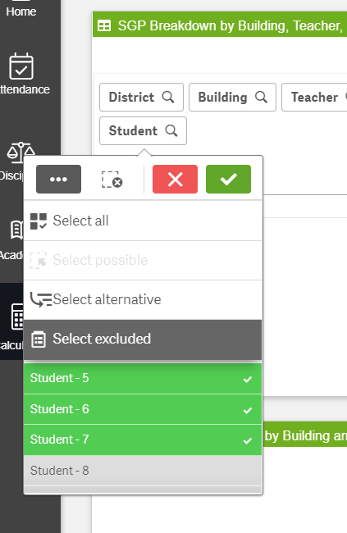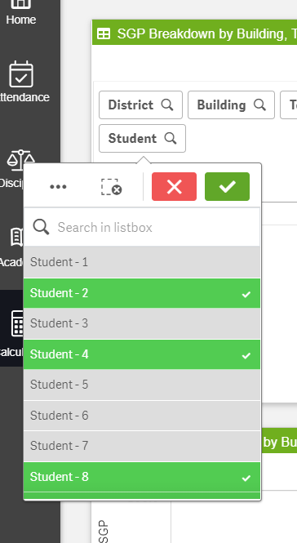
After “select excluded”

- To verify which students were excluded, scroll to the bottom of the dropdown list. Excluded students will now appear in grey.
